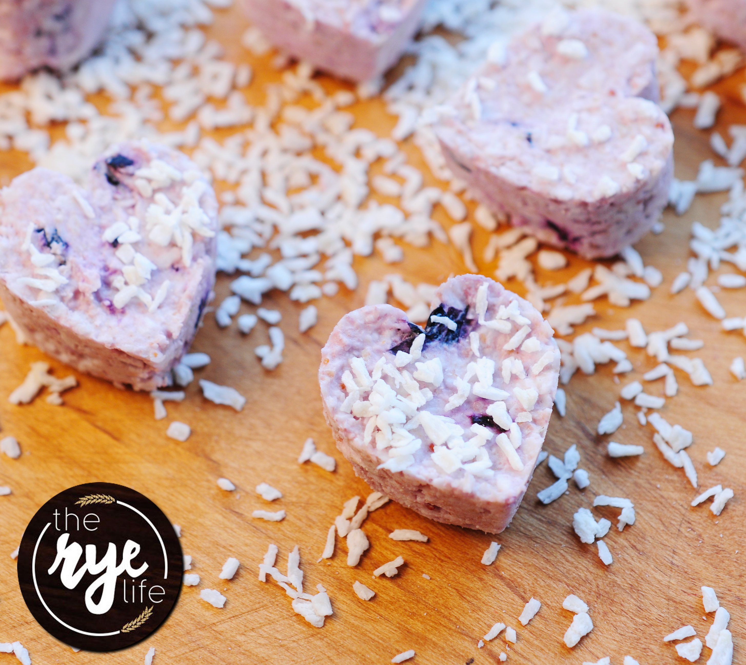
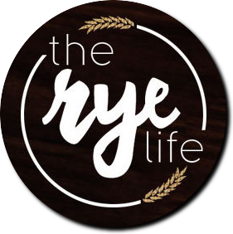
Coconut and Blueberry Bites
Serves 20 / 50 Minutes / Easy
Nutritional Content Per Bite
Calories | 70 | Sodium | 0 mg
Total Fat | 6 g | Potassium | 4 mg
Saturated | 5 g | Total Carbs | 4 g
Polyunsaturated | 0 g | Dietary Fibre | 1 g
Monounsaturated | 0 g | Sugars | 2 g
Trans | 0 g | Protein | 1 g
Cholesterol | 0 mg
Vitamin A | 0% | Calcium | 0%
Vitamin C | 0% | Iron | 0%
You will need:
1 1/3 cup of Desiccated Coconut
1 cup of Oatbran
3 tablespoons of Coconut Oil
3 tablespoons of Soya Yoghurt
1 tablespoon Pure Maple Syrup
2 teaspoons of Vanilla Extract
2/3 cups Blueberries
A shape mould of your choice
Method:
1) Add 1 cup of the desiccated coconut, 2/3 of the Oatbran and all of the coconut oil into a bowl and stir.
2) Then add the yoghurt along with the rest of the desiccated coconut and Oatbran and stir to make a mix. The mix will dry up again with the rest of the coconut and Oatbran.
3) Add the maple syrup, vanilla extract, the blueberries and either blitz in a food processor or mash in the bowl.
4) Using a teaspoon, spoon the mix into your mould, OR if you’d like to make them into balls, cover the bowl in cling film and place in the fridge for 30 minutes.
5) Take the mix or mould with filling out of the fridge and either release the shapes from the moulds or alternatively for the balls, take small sections of the mix, and roll into balls.
6) Cover a clean surface with some of the desiccated coconut and sprinkle your shapes or balls in the coconut.
7) Enjoy as a snack on the go or with friends mid morning for a great energy and fibre boost!

